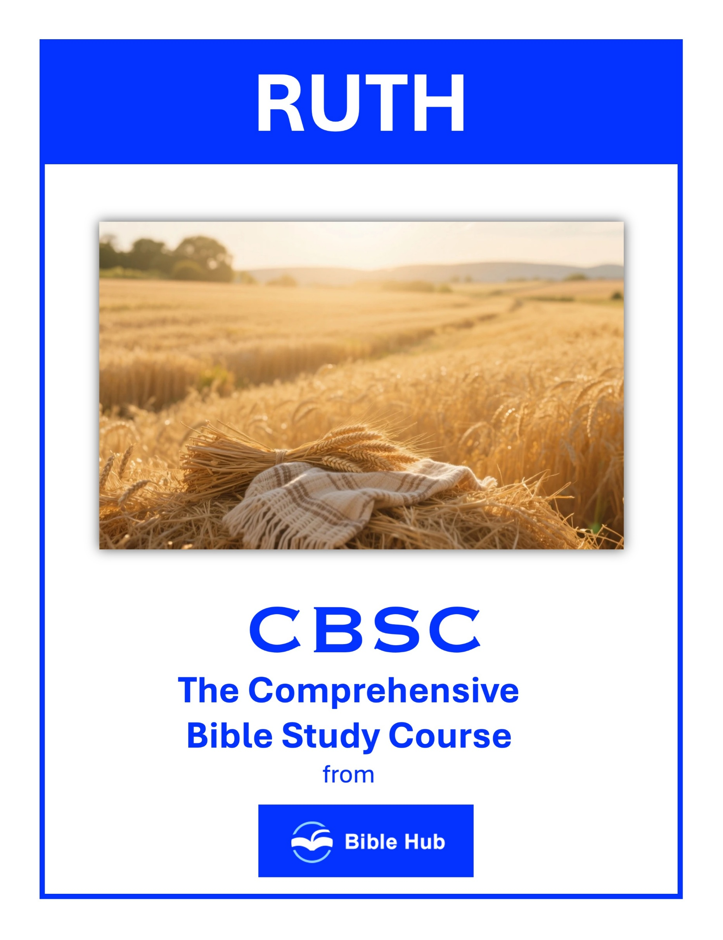

Ruth 1 Teaching Points and Bible Study Questions
Loyalty in Times of Trial
Ruth's unwavering loyalty to Naomi is a powerful testament to the strength of commitment. Despite the uncertainty and hardship, Ruth declares, "Where you go, I will go, and where you stay, I will stay" (Ruth 1:16). This teaches us the importance of standing by our loved ones, even when the path is unclear. Loyalty is a reflection of our faithfulness, mirroring the steadfast love God shows us.
1. How can you demonstrate loyalty to loved ones during challenging times, like Ruth did with Naomi?
2. What motivates you to stay committed to relationships when facing personal trials?
3. Why do you think loyalty is important in maintaining strong bonds during difficult periods?
Embrace New Beginnings
Ruth's decision to leave her homeland and embrace a new life in Bethlehem is a reminder that God often calls us to step out in faith. "Your people will be my people, and your God will be my God" (Ruth 1:16) signifies her willingness to embrace change and trust in God's plan. We, too, can find courage in new beginnings, knowing that God is with us every step of the way.
1. How can embracing new beginnings in your life lead to unexpected blessings, like Ruth's journey with Naomi?
2. What do you hope to gain by stepping into unfamiliar situations, as Ruth did when leaving Moab?
3. Why do you think it's important to trust in new paths, even when the outcome is uncertain?

The Power of Choice
Ruth's story highlights the power of choice in shaping our destiny. By choosing to stay with Naomi, Ruth sets the stage for a future filled with God's blessings. Our choices, guided by Scripture and prayer, can lead us closer to God's purpose for our lives. "But Ruth replied, 'Do not urge me to leave you or to turn back from following you'" (Ruth 1:16).
1. How can Ruth's choice to stay with Naomi inspire your decisions in challenging relationships?
2. What do you hope to gain by choosing loyalty over convenience in your life?
3. Why does Naomi's return to Bethlehem highlight the importance of choosing faith over despair?
Faith in the Face of Uncertainty
Ruth's journey is marked by uncertainty, yet her faith never wavers. Her story encourages us to trust in God's provision, even when the future seems unclear. "May the LORD deal with me, be it ever so severely, if even death separates you and me" (Ruth 1:17) reflects her deep trust in God's faithfulness.
1. How can you maintain faith when facing uncertain life changes like Ruth and Naomi did?
2. What do you hope to gain by trusting in God's plan during uncertain times?
3. Why does faith become challenging when the future is unclear, and how can you overcome this?

The Importance of Community
Naomi and Ruth's relationship underscores the importance of community and support. In times of need, having a community to lean on can make all the difference. "So Naomi returned from the land of Moab with her daughter-in-law Ruth the Moabitess" (Ruth 1:22). We are reminded that we are not meant to walk this journey alone.
1. How can you support someone in your community facing a difficult transition like Naomi and Ruth?
2. Why do you think Ruth chose to stay with Naomi instead of returning to her own family?
3. What can you do to strengthen bonds within your community during challenging times?

God's Providence in Our Lives
Ruth's story is a beautiful illustration of God's providence. Despite the challenges, God orchestrates events for Ruth's good and His glory. "The LORD has afflicted me; the Almighty has brought misfortune upon me" (Ruth 1:21) shows Naomi's initial despair, yet God's hand is at work, preparing a future of hope.
1. How can you recognize God's providence in challenging situations like Naomi's journey to Moab?
2. What do you hope to learn from Ruth's loyalty about trusting God's plan in your life?
3. Why do you think Naomi's return to Bethlehem signifies trust in God's provision despite past hardships?

The Strength of a Humble Heart
Ruth's humility is evident in her willingness to serve Naomi and adapt to a new culture. Her humble heart opens doors to God's blessings. "Call me Mara, because the Almighty has dealt quite bitterly with me" (Ruth 1:20) reflects Naomi's bitterness, yet Ruth's humility brings healing and restoration.
1. How can Ruth's humility inspire you to show strength in challenging relationships today?
2. Why do you think humility is essential for building strong, supportive communities?
3. What can you learn from Naomi's journey about finding strength in vulnerability?
Hope Amidst Despair
Even in the darkest times, Ruth's story reminds us that hope is never lost. Naomi's return to Bethlehem marks the beginning of a new chapter, filled with God's promises. "So Naomi returned from the land of Moab" (Ruth 1:22) signifies a turning point, where hope begins to blossom once more.
1. How can you find hope in difficult situations like Naomi and Ruth did in Ruth 1?
2. What do you hope to learn from Ruth's loyalty and faith during times of despair?
3. Why do you think Naomi's return to Bethlehem symbolizes hope despite her initial despair?

The Impact of a Godly Influence
Naomi's influence on Ruth is profound, guiding her towards faith in the one true God. Our lives can similarly impact others, leading them to Christ. "Your God will be my God" (Ruth 1:16) is a testament to the power of a godly example, encouraging us to live out our faith authentically.
1. How can you be a godly influence in your family during challenging times like Naomi was to Ruth?
2. Why do you think Ruth chose to follow Naomi's God, and how can you inspire similar faith in others?
3. What can you do to ensure your actions positively impact those around you, as Naomi did for Ruth?
Trusting God's Timing
Ruth's journey teaches us to trust in God's perfect timing. Though the road may be long and filled with challenges, God's plan unfolds in His time. "They arrived in Bethlehem at the beginning of the barley harvest" (Ruth 1:22) signifies a season of new beginnings, reminding us that God's timing is always right.
1. How can you trust God's timing when facing uncertainty like Naomi and Ruth did?
2. What do you hope to learn about patience from Ruth's journey to Bethlehem?
3. Why do you think Ruth chose to trust God's plan despite immediate hardships?

Ruth 2 Teaching Points and Bible Study Questions
Divine Providence in Action
In Ruth 2, we see God's hand guiding Ruth to Boaz's field, illustrating the concept of divine providence. As Ruth sets out to glean, she "happened to come to the part of the field belonging to Boaz" (Ruth 2:3). This wasn't mere coincidence; it was God's orchestration. In our lives, we can trust that God is directing our steps, even when we aren't aware of it. Remember, "The heart of man plans his way, but the LORD establishes his steps" (Proverbs 16:9).
1. How can you recognize and respond to divine providence in your daily life like Ruth did?
2. What do you hope to learn from Ruth's trust in God's provision during uncertain times?
3. Why does Boaz's kindness inspire you to act as an instrument of divine providence for others?
The Power of Kindness
Boaz's kindness towards Ruth is a powerful reminder of how our actions can reflect God's love. He tells her, "May the LORD reward your work, and may you receive a full reward from the LORD, the God of Israel, under whose wings you have come to seek refuge" (Ruth 2:12). Boaz's generosity and protection are a model for us to show kindness to others, especially those in need.
1. How can you show kindness to strangers in your community, like Boaz did for Ruth?
2. Why do you think kindness can create opportunities for deeper relationships, as seen with Ruth and Boaz?
3. What can you do to cultivate a culture of kindness in your workplace or school?

Hard Work and Diligence
Ruth's dedication to providing for Naomi is evident in her hard work. She "gleaned in the field until evening" (Ruth 2:17), demonstrating diligence and perseverance. This teaches us the value of hard work and the importance of being industrious in our endeavors, trusting that God will bless our efforts.
1. How can Ruth's example of hard work inspire your approach to challenges in your daily life?
2. Why do you think diligence is important in achieving personal and professional goals?
3. What can you learn from Ruth about maintaining integrity and perseverance in difficult situations?
Humility and Gratitude
Ruth's humility is evident when she bows down and asks Boaz, "Why have I found favor in your eyes, that you should take notice of me, since I am a foreigner?" (Ruth 2:10). Her gratitude for Boaz's kindness is a lesson for us to remain humble and thankful for the blessings we receive, recognizing that they are gifts from God.
1. How can Ruth's humility in seeking help inspire your approach to asking for assistance in life?
2. What practical steps can you take to express gratitude like Ruth did towards Boaz?
3. Why do you think humility and gratitude are important in building strong relationships today?

The Importance of Community Support
Boaz instructs his workers to allow Ruth to glean among the sheaves and even leave extra grain for her (Ruth 2:15-16). This act of community support highlights the importance of looking out for one another. As believers, we are called to bear one another's burdens and support each other in times of need.
1. How can you actively support someone in your community facing difficult circumstances, like Boaz did for Ruth?
2. Why do you think community support is crucial for personal growth and resilience, as seen in Ruth's story?
3. What can you do to foster a welcoming and supportive environment in your community, similar to Boaz's actions?

God's Provision Through Others
Ruth's story shows how God often provides for us through the generosity of others. Boaz's actions are a testament to how God uses people to fulfill His purposes. "And my God will supply all your needs according to His glorious riches in Christ Jesus" (Philippians 4:19) is a promise we can hold onto, knowing that God will meet our needs through various means.
1. How can you recognize and accept God's provision through others in your daily life?
2. Why do you think God uses people to provide for others, and how can you participate?
3. What can you do to become a channel of God's provision for those around you?

Faithfulness in Relationships
Ruth's loyalty to Naomi is a beautiful example of faithfulness in relationships. Her commitment to stay with Naomi and support her is a reflection of the steadfast love we are called to show in our relationships. "Where you go, I will go, and where you stay, I will stay" (Ruth 1:16) is a declaration of unwavering loyalty that we can emulate.
1. How can you demonstrate faithfulness in your relationships like Ruth did with Naomi?
2. What do you hope to gain by being faithful in your relationships?
3. Why does faithfulness in relationships matter in building trust and community?
The Role of Integrity
Boaz's integrity is evident in his dealings with Ruth. He ensures her safety and provides for her without expecting anything in return. His actions remind us of the importance of maintaining integrity in all our interactions, reflecting the character of Christ in our lives.
1. How can Ruth's integrity in her work inspire your approach to daily responsibilities?
2. Why do you think Boaz valued integrity, and how can you apply this in your relationships?
3. What can you learn from Ruth's integrity that might influence your decision-making in challenging situations?

God's Redemption Plan
Ruth's story is a foreshadowing of God's ultimate redemption plan through Jesus Christ. Boaz, as a kinsman-redeemer, points to Christ, our Redeemer, who came to save us from sin. "For the Son of Man came to seek and to save the lost" (Luke 19:10) is the heart of the gospel message, and Ruth's story beautifully illustrates this theme.
1. How can Boaz's kindness inspire you to participate in God's redemption plan in your community?
2. What do you hope to learn from Ruth's trust in God's provision during challenging times?
3. Why does God's redemption plan often involve unexpected people and circumstances, like Ruth and Boaz?
Hope in Uncertain Times
Ruth's journey from Moab to Bethlehem is filled with uncertainty, yet she remains hopeful. Her story encourages us to hold onto hope, even when the future seems unclear. "For I know the plans I have for you, declares the LORD, plans to prosper you and not to harm you, plans to give you hope and a future" (Jeremiah 29:11) is a promise that we can cling to, trusting that God has a good plan for our lives.
1. How can Ruth's actions in uncertain times inspire your approach to challenges today?
2. What do you hope to learn from Ruth's perseverance and faith in difficult situations?
3. Why does Boaz's kindness offer a model for providing hope to others in uncertain times?

Ruth 3 Teaching Points and Bible Study Questions
Embrace Humility and Service
In Ruth 3, we see Ruth's humility and willingness to serve Naomi. She follows Naomi's instructions without hesitation, demonstrating a heart of service. This reminds us of Philippians 2:3, "Do nothing out of selfish ambition or empty pride, but in humility consider others more important than yourselves." Ruth's example encourages us to serve others selflessly, trusting that God will honor our humility.
1. How can you demonstrate humility and service in your daily interactions like Ruth did with Boaz?
2. Why do you think humility is essential in building strong, supportive relationships?
3. What practical steps can you take to serve others selflessly in your community?
Seek Wise Counsel
Ruth listens to Naomi's guidance, showing the importance of seeking wise counsel. Proverbs 15:22 tells us, "Plans fail for lack of counsel, but with many advisers they succeed." Surrounding ourselves with godly mentors can help us navigate life's challenges with wisdom and discernment.
1. How can seeking wise counsel impact your decision-making in challenging situations like Ruth's approach to Boaz?
2. Why do you think Naomi's guidance was crucial for Ruth, and how can you apply this in your life?
3. What can you learn from Ruth about trusting and acting on wise advice in uncertain circumstances?

Take Bold Steps of Faith
Ruth's approach to Boaz on the threshing floor was a bold step of faith. She trusted in God's provision and took action. Hebrews 11:6 reminds us, "And without faith it is impossible to please God." Sometimes, stepping out in faith is necessary to see God's plans unfold in our lives.
1. How can you take bold steps of faith in your current relationships, like Ruth did with Boaz?
2. What do you hope to achieve by stepping out in faith in a challenging situation?
3. Why do you think taking risks in faith is important for personal growth and spiritual development?
Trust in God's Timing
Ruth's story is a testament to the importance of trusting in God's perfect timing. Ecclesiastes 3:11 says, "He has made everything beautiful in its time." Ruth's patience and trust in God's timing led to her becoming part of the lineage of Christ, showing us that waiting on the Lord is always worth it.
1. How can you practice patience while waiting for God's timing in your current situation?
2. What do you hope to learn about trust from Ruth's example in waiting for Boaz's response?
3. Why does trusting God's timing sometimes feel challenging, and how can you overcome these feelings?

Honor and Integrity Matter
Boaz's response to Ruth's request highlights the importance of honor and integrity. He acts with righteousness, ensuring that everything is done properly. Proverbs 11:3 states, "The integrity of the upright guides them." Living with integrity honors God and builds trust with others.
1. How can you demonstrate honor and integrity in challenging situations like Ruth did with Boaz?
2. Why do you think maintaining integrity is crucial in building trust and relationships today?
3. What can you learn from Ruth and Boaz about handling sensitive matters with respect and honesty?
God Provides for the Faithful
Ruth's faithfulness to Naomi and God did not go unnoticed. Boaz's generosity towards her is a reminder of God's provision for those who are faithful. Philippians 4:19 assures us, "And my God will supply all your needs according to His glorious riches in Christ Jesus."
1. How can you trust God's provision in uncertain situations like Ruth did with Boaz?
2. What steps can you take to actively seek God's guidance in your daily decisions?
3. Why do you think faithfulness is important in experiencing God's provision in your life?

The Power of Redemption
Boaz's role as a kinsman-redeemer foreshadows Christ's redemptive work. Just as Boaz redeemed Ruth, Jesus redeems us. Ephesians 1:7 declares, "In Him we have redemption through His blood, the forgiveness of our trespasses, according to the riches of His grace."
1. How can you identify and embrace opportunities for redemption in your own life like Ruth did?
2. Why do you think Boaz's actions demonstrate the power of redemption in relationships?
3. What can you learn from Ruth's trust in Boaz about seeking redemption in challenging situations?
God Works Through Ordinary People
Ruth was a Moabite widow, yet God used her in His grand plan. This reminds us that God often works through ordinary people to accomplish extraordinary things. 1 Corinthians 1:27 says, "But God chose the foolish things of the world to shame the wise."
1. How can you recognize and embrace God's work in your everyday interactions like Ruth did with Boaz?
2. Why do you think God chooses to work through ordinary people rather than extraordinary means?
3. What practical steps can you take to be open to God's guidance in your daily life?

Love and Loyalty are Powerful
Ruth's love and loyalty to Naomi are central themes in her story. Her unwavering commitment is a powerful example of love in action. John 15:13 tells us, "Greater love has no one than this: to lay down one’s life for one’s friends."
1. How can you demonstrate love and loyalty in your relationships like Ruth did with Naomi and Boaz?
2. Why do you think loyalty is essential in building strong, lasting relationships today?
3. What can you learn from Ruth's actions about balancing love and loyalty in challenging situations?
God's Plans are Greater Than Our Own
Ruth's journey from widowhood to becoming the great-grandmother of King David shows that God's plans are far greater than we can imagine. Jeremiah 29:11 reassures us, "For I know the plans I have for you, declares the LORD, plans to prosper you and not to harm you, plans to give you hope and a future." Trusting in God's plan brings hope and purpose to our lives.
1. How can you trust God's plans when your own seem more appealing or immediate?
2. What do you hope to learn from Ruth's patience and faith in God's timing?
3. Why does relying on God's plans require letting go of personal control, and how can you practice this?

Ruth 4 Teaching Points and Bible Study Questions
Redemption is a Gift of Grace
In Ruth 4, we witness Boaz stepping in as the kinsman-redeemer, a beautiful picture of grace and redemption. Just as Boaz redeemed Ruth, we are reminded of our own redemption through Christ. Ephesians 1:7 tells us, "In Him we have redemption through His blood, the forgiveness of our trespasses, according to the riches of His grace." This story encourages us to embrace the grace that has been freely given to us and to live in gratitude for the ultimate redemption we have in Jesus.
1. How can you recognize and accept redemption as a gift of grace in your daily life?
2. Why do you think Boaz's actions reflect God's grace, and how can you emulate this?
3. What can you do to extend grace and redemption to others in your community?
God’s Providence is Always at Work
The events in Ruth 4 highlight how God orchestrates circumstances for His purposes. From Ruth's loyalty to Naomi to Boaz's willingness to redeem, every detail was part of God's divine plan. Proverbs 16:9 reminds us, "A man’s heart plans his course, but the LORD determines his steps." Trust that God is working behind the scenes in your life, even when you can't see it.
1. How can you recognize and trust God's providence in unexpected life changes, like Ruth's marriage to Boaz?
2. What do you hope to learn from Ruth's story about God's timing in your own life?
3. Why does understanding God's providence encourage you to act faithfully in challenging situations?

Faithfulness Leads to Blessing
Ruth's faithfulness to Naomi and Boaz's integrity are central themes in this chapter. Their commitment to doing what is right leads to blessings beyond their imagination. As Galatians 6:9 encourages, "Let us not grow weary in well-doing, for in due time we will reap a harvest if we do not give up." Stay faithful in your walk, and trust that God will honor your commitment.
1. How can you demonstrate faithfulness in your daily life to receive blessings like Ruth and Boaz?
2. Why do you think faithfulness is crucial in building strong relationships and communities?
3. What can you learn from Ruth's faithfulness that applies to your personal or professional life?
Community Matters
The community plays a significant role in Ruth 4, witnessing and affirming the redemption process. This reminds us of the importance of being part of a supportive faith community. Hebrews 10:24-25 urges us, "And let us consider how to spur one another on to love and good deeds. Let us not neglect meeting together, as some have made a habit, but let us encourage one another." Surround yourself with believers who will uplift and encourage you.
1. How can you contribute to your community's well-being, similar to Boaz's role in Ruth 4?
2. Why do you think community support was crucial in Ruth and Boaz's story?
3. What can you do to ensure your community thrives like the one in Ruth 4?

God’s Plans Surpass Our Expectations
Ruth and Naomi's story ends with a lineage that leads to King David and ultimately to Jesus. This outcome was far beyond what they could have imagined. Ephesians 3:20 reminds us, "Now to Him who is able to do immeasurably more than all we ask or imagine, according to His power that is at work within us." Trust that God’s plans for you are greater than you can envision.
1. How can you trust God's plans when your expectations aren't met, like Ruth and Naomi did?
2. What do you hope to learn from unexpected outcomes in your life, as seen in Ruth 4?
3. Why does embracing God's plans lead to greater fulfillment than sticking to your own expectations?

Legacy of Faith
The genealogy at the end of Ruth 4 highlights the importance of a legacy of faith. Ruth and Boaz's story is a testament to how God can use ordinary people to fulfill His extraordinary purposes. Psalm 145:4 says, "One generation will commend Your works to the next, and they shall proclaim Your mighty acts." Consider the legacy of faith you are building for future generations.
1. How can you actively contribute to a legacy of faith in your family or community today?
2. What do you hope your faith legacy will inspire in future generations?
3. Why does Boaz's decision impact the legacy of faith for his descendants, and how can you emulate this?

God Honors Humility
Ruth's humble spirit and willingness to serve are evident throughout the book. Her humility is rewarded with a place in the lineage of Christ. James 4:10 encourages us, "Humble yourselves before the Lord, and He will exalt you." Embrace humility in your life, knowing that God honors those who serve with a humble heart.
1. How can you demonstrate humility in your daily interactions, as Boaz did in his dealings with others?
2. Why do you think God values humility, and how can this influence your personal and professional life?
3. What practical steps can you take to cultivate humility, following Ruth's example in her relationship with Naomi?
Love is a Powerful Force
The love story between Ruth and Boaz is a testament to the power of love rooted in faithfulness and commitment. 1 Corinthians 13:7 reminds us, "Love bears all things, believes all things, hopes all things, endures all things." Let love be the driving force in your relationships, reflecting the love of Christ to those around you.
1. How can Boaz's actions in Ruth 4 inspire you to show love in your community today?
2. Why do you think love motivated Boaz to fulfill his role as a kinsman-redeemer?
3. What can you learn from Ruth and Boaz about love's impact on family and legacy?

God Uses the Unexpected
Ruth, a Moabite widow, becomes part of the lineage of Christ, showing that God often uses the unexpected to fulfill His purposes. 1 Corinthians 1:27 states, "But God chose the foolish things of the world to shame the wise; God chose the weak things of the world to shame the strong." Be open to how God might use you in unexpected ways.
1. How can you recognize and embrace unexpected opportunities God presents in your daily life?
2. Why do you think God often uses unexpected people or events to fulfill His plans?
3. What can you do to remain open to God's unexpected guidance in challenging situations?
Hope in God’s Promises
The conclusion of Ruth 4 is a reminder of the hope found in God’s promises. The birth of Obed brings joy and restoration to Naomi, symbolizing the fulfillment of God’s promises. Romans 15:13 encourages us, "May the God of hope fill you with all joy and peace as you trust in Him, so that you may overflow with hope by the power of the Holy Spirit." Hold fast to the hope that God’s promises bring, knowing they are sure and steadfast.
1. How can you find hope in God's promises when facing uncertain situations like Ruth and Naomi did?
2. What do you hope to learn from Boaz's faithfulness in fulfilling God's promises?
3. Why does trusting in God's promises provide hope during challenging times in your life?

